姓名 | 张家骏
教育与工作经历 | 2024 – Present · Southern University of Science and Technology · Automation
电子邮箱 | 12410513@mail.sustech.edu.cn
个人照片 | 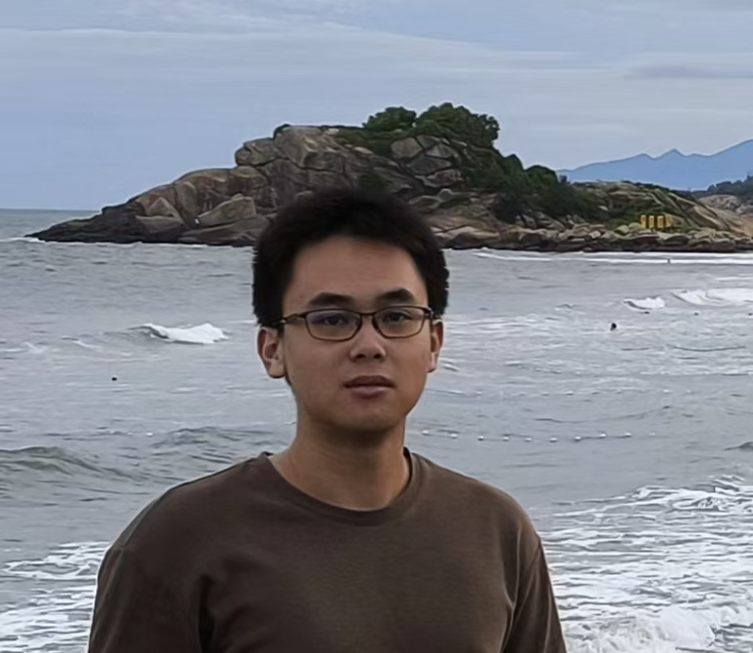
研究领域 | Robotics & Control Systems; Embedded Systems & Hardware-Software Co-Design.
自我介绍 | I’m Zhang JiajunI am an undergraduate student majoring in Automation at Southern University of Science and Technology . My interests lie at the intersection of robotics, control theory, and application computer vision. I would like to explore new things across different fields.
论文发表情况 | （如无论文，此处留空）
填写参考：https://bird-lab.org/people

